**Image Recognition with IBM Cloud Visual Recognition**

Project Title: Image Recognition

PROBLEMSTATEMENT

Our goal is to develop an AI-powered system that allows users to upload images, automatically recognizes and classifies the contents of these images, generates descriptive captions using natural language generation, and provides features for users to engage with and share their AI-enhanced images.

PROJECT OBJECTIVES

1. Set up the IBM Cloud Visual Recognition service and obtain the necessary API keys.
2. Design a user-friendly interface for image uploads and viewing AI-generated captions.
3. Implement image classification using the IBM Cloud Visual Recognition API.
4. Integrate natural language generation to create captions for recognized images.
5. Develop user engagement features to explore, save, and share AI-enhanced images.

APPROACH METHOD

1. Project Kick-off and Planning:

* Define the project scope, objectives, and requirements.
* Create a detailed project plan, including timelines and milestones.

2. Research and Familiarization:

* Study IBM Cloud Visual Recognition documentation to understand its capabilities and limitations.

3. IBM Cloud Visual Recognition Setup:

* Sign up for an IBM Cloud account
* Create an instance of the Watson Visual Recognition service.
* Obtain API keys and configure the service for image classification.

4. User Interface Design:

* Design a web-based interface.
* Include image upload functionality.
* Display recognition results and generated captions.

5. Frontend Development:

* Develop the frontend of the user
* interface using web technologies (HTML, CSS, JavaScript) or relevant mobile app frameworks.
* Implement image upload functionality
* Design the user interface to display recognition results and generated captions.

6. Backend Development:

* Develop the backend logic to handle user requests and communicate with the Visual Recognition API.
* Implement a secure authentication system for users if required.
* Set up a database to store user data and preferences.

7. Image Classification Integration:

* Build functions to send user-uploaded images to the Visual Recognition service.
* Process and interpret classification results returned by the API.

8. AI-Generated Captions Integration:

* Integrate a natural language generation model into the system.
* Pass recognized image classes to the language model to generate captions.

9. User Engagement Features:

* Develop user account and profile management features. Implement options for users to save their favourite images and generate captions.
* Enable social media sharing functionality for users to share their AI-enhanced images.

10. Project Review and Future Enhancements:

* Review the project's success against initial objectives.

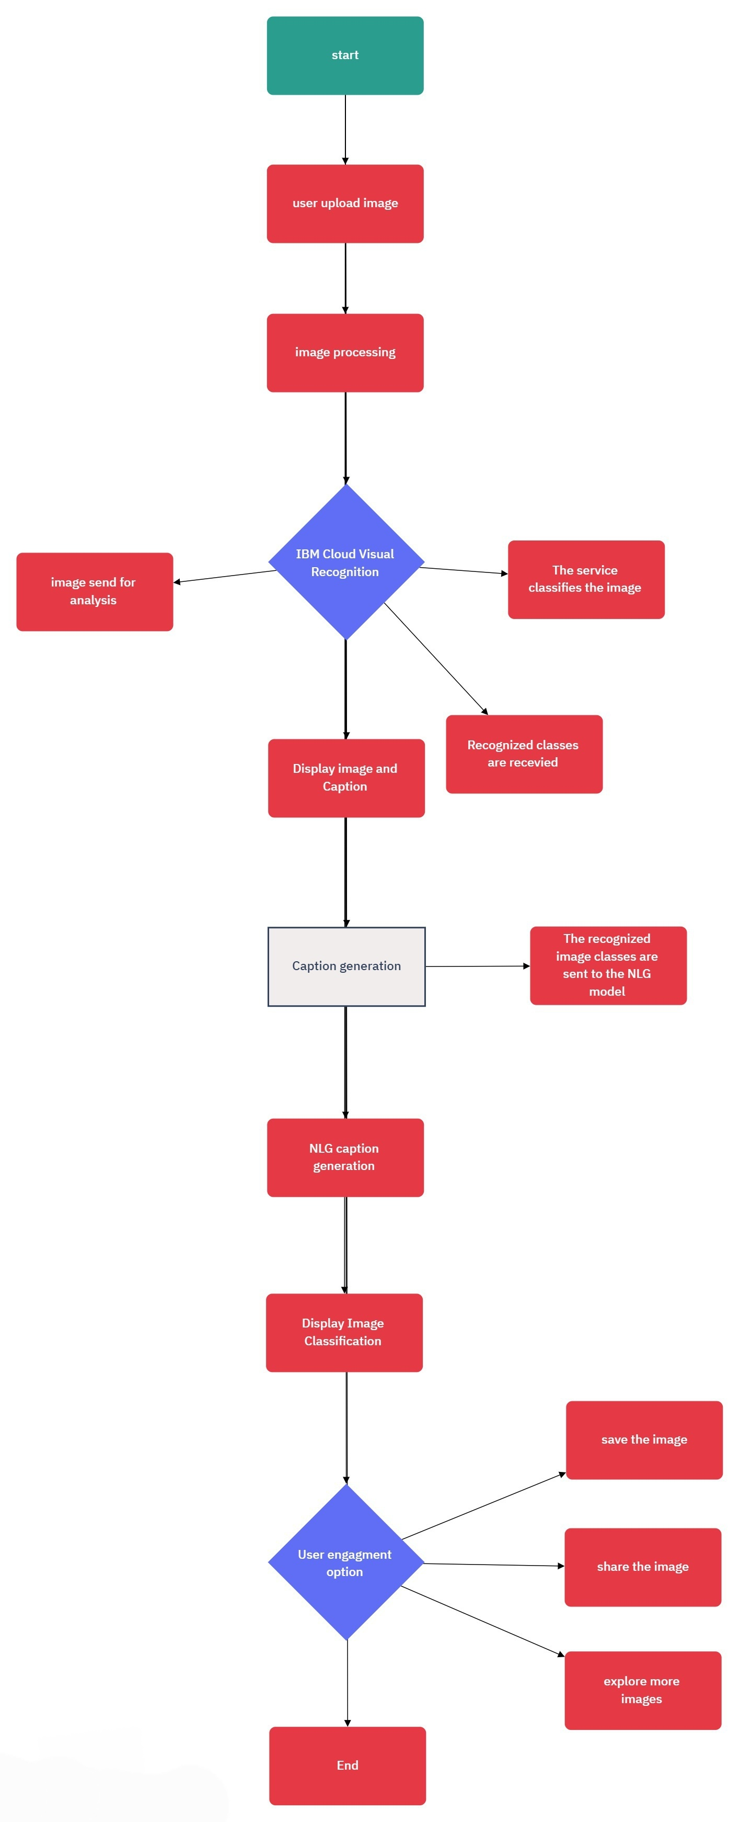

IMPLEMENTATION FLOW CHART

DESIGN THINKING

**Empathize**

1. User Interviews:

* Begin by conducting interviews with photographers and users interested in visual storytelling.

2. User Stories:

* Create user personas representing different user types, such as professional photographers and hobbyists. Develop detailed user stories to empathize with their experiences.

3. Market Research:

* Study existing image recognition and storytelling platforms to identify what works, what doesn't, and gaps in the market.

**Ideate**:

1. Brainstorm Features:

* Organize brainstorming sessions with your team to generate ideas for features and functionalities.
* Encourage creativity in finding solutions to user needs

2. Feature Prioritization:

* Prioritize features using techniques like user story mapping or the MoSCoW method.
* Identify the must-have features for your Minimum Viable Product (MVP).

**Implement**:

1. Development:

* Begin the development process, incorporating the refined design and feature decisions from the prototyping and testing phases.

2. Integration:

* Implement integration with IBM Cloud Visual Recognition and the chosen natural language generation model

**Prototype**:

1. Design Prototyping:

* Create low-fidelity wireframes and mockups for the user interface, focusing on features like image upload, classification display, and caption generation.

2. Interactive Prototypes:

* Develop interactive prototypes for key features to visualize the user journey and gather early feedback. Tools like Figma or Adobe XD can be useful.

**Feedback Analysis**:

* Analyze user feedback to refine your design and feature decisions. Iterate on your prototypes based on insights gained during testing.

CONCLUSION

Captivate makes storytelling with images easy. It recognizes your photos and adds captivating captions, helping you connect with your audience effortlessly.